


Super-heterodyne Receiver & FDM Communication System


Student Name: Basel Shrief Hemaid Moustafa باسل شريف حميد مصطفى
Code: 91240202
Academic Year: 2025/2026
Course: Communication, Analog Communication Part

Supervised By: Dr. Ahmed Hesham Mehana

1. Introduction
This project simulates an end-to-end analog communication system using MATLAB. The system implements Double Sideband-Suppressed Carrier (DSB-SC) modulation to multiplex two audio signals (Station A at 100 kHz and Station B at 130 kHz) into a Frequency Division Multiplexed (FDM) signal.
To recover the transmitted signal, a Super-heterodyne receiver is implemented. Unlike a homodyne receiver, the super-heterodyne architecture utilizes an intermediate frequency (IF) stage to improve selectivity and avoid issues such as flicker noise and DC offsets.

2. System Implementation & Results
(Note: The following sections directly address the deliverables requested in the project specification.)

Question 1: Roles of Receiver Stages
The super-heterodyne receiver consists of three main stages, each serving a distinct purpose:
- RF Stage (Radio Frequency): The primary role of the RF bandpass filter is Image Rejection. It acts as a coarse filter to isolate the desired station's frequency band and block the "image frequency" (F_{image} = F_{c} + 2F_{IF}) before it reaches the mixer.
- IF Stage (Intermediate Frequency): After the mixer down-converts the signal, the IF stage provides High Selectivity.
  - Why we need the IF stage: Building tunable, high-Q (highly selective) filters at high, variable RF frequencies is physically difficult. By mixing all desired stations down to a single, fixed IF frequency (15 kHz), we can use a highly optimized, sharp bandpass filter to cleanly separate adjacent channels.
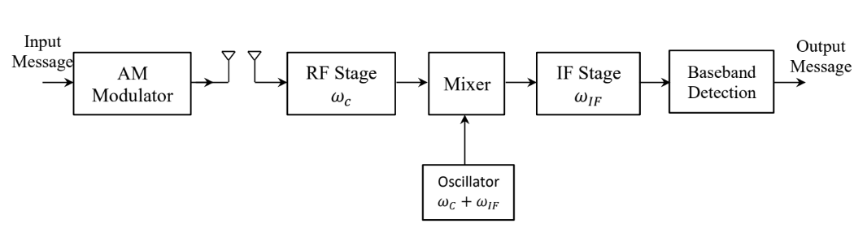
- Baseband Detector: This stage performs coherent demodulation by multiplying the IF signal with a synchronized local oscillator (cos (W_{IF}t)) and applying a Low-Pass Filter (LPF). This shifts the signal from the IF back to the audible baseband (0 Hz) and removes high-frequency mixer products.

Figure 1: Receiver's Blocks

Question 2: Spectral Analysis of Receiver Stages
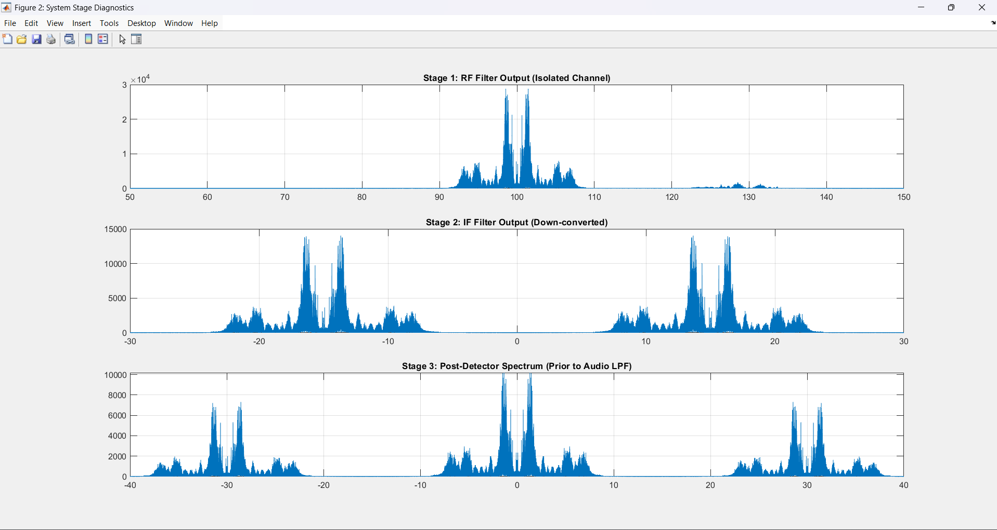
To demodulate the first station (F_{c} = 100 kHz), the receiver processes the multiplexed signal through the RF, IF, and Baseband stages.
Figure 2: Plots for the 3 stages
Observation:
- Top Plot (RF Stage): Shows the spectrum centered at 100 kHz. Station 2 (130 kHz) has been successfully attenuated by the RF filter.
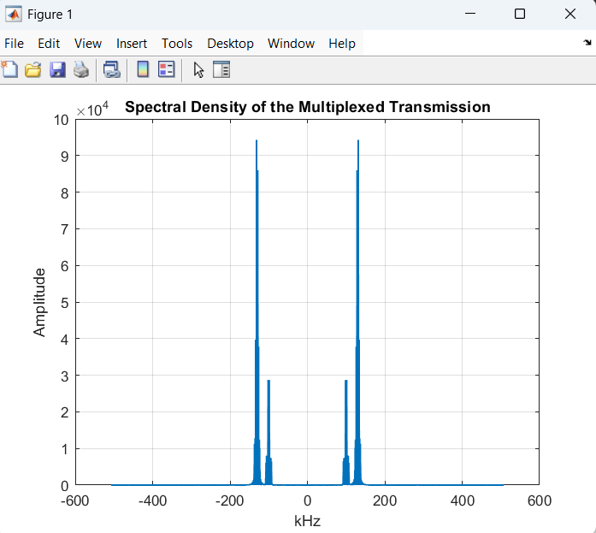
- Middle Plot (IF Stage): The mixer (F_{LO} = 115 kHz) has successfully shifted the 100 kHz signal down to exactly 15 kHz.
- Bottom Plot (Baseband): The synchronous detector has shifted the 15 kHz signal down to 0 Hz, ready for audio playback, successfully recovering the original message envelope.

Figure 3: Density of the two Messages in the Frequency domain

Question 3: Audio Verification (sound command)
I have a Comment on Audio Recovery:
The recovered signal for Station 1 was successfully played using the sound command and exported via audio write. The audio was clear and intelligible, matching the original baseband recording.
Note on Implementation: Because the simulation required a high sampling rate (F_{s} = 1 MHz) to satisfy the Nyquist criterion for the 130 kHz carrier, the sound command initially exceeded hardware limits. The recovered signal had to be decimated (down sample function) back to its original sampling rate (~44.1 kHz) prior to playback.

Question 4: Removal of the RF BPF (Image Interference)
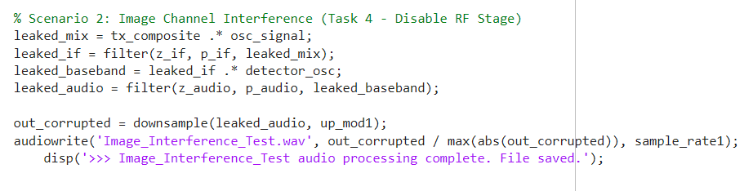
To test the necessity of the RF stage, the RF BPF was bypassed, feeding the entire FDM spectrum directly into the mixer.
Figure 4: Part of code for Image Channel Interference test
What Happens: When attempting to demodulate Station 1 (100 kHz) without the RF stage, the audio becomes severely corrupted, and both stations are heard simultaneously.
Theoretical Explanation: The local oscillator is set to 115 kHz.
- The desired station (100 kHz) produces an IF of: |115 - 100| = 15 kHz.
- The interfering station (130 kHz) produces an IF of: |115 - 130| = 15 kHz.
Because 130 kHz is exactly F_{c} + 2F_{IF}, it acts as the Image Frequency. Without the RF filter to block it beforehand, the mixer folds both stations onto the exact same 15 kHz IF band, making them impossible to separate later.

Question 5: LO Frequency Offsets
To achieve successful coherent demodulation, the receiver's oscillator must be perfectly synchronized with the transmitter. If an offset ΔF exists, the recovered baseband signal is multiplied by cos (2π ΔFt).
1. Frequency Offset of 0.1 KHz (100 Hz):
- Spectrum: The entire baseband spectrum is shifted by 100 Hz.
- Sound Quality: The audio exhibits a slow, rhythmic "beating" or fading effect. Because 100 Hz is a relatively low frequency, the voice is still somewhat recognizable but oscillates rapidly in volume as the cos(2π . 100 . t) envelope cycles between 1 and 0.
2. Frequency Offset of 1 KHz (1000 Hz):
- Spectrum: The baseband spectrum is severely shifted by 1000 Hz, misaligning the harmonic structure of the human voice.
- Sound Quality: The audio is completely scrambled and unintelligible. It sounds highly robotic and distorted, demonstrating a total loss of synchronization.

III. Conclusion
The simulation successfully verified the operational principles of FDM and super-heterodyne reception. The project highlighted the critical necessity of the RF stage for image rejection, the efficiency of the IF stage for channel selectivity, and the absolute requirement for strict oscillator synchronization to maintain signal integrity.

IV. References and Links
1- MATLAB Codes in a GitHub Repository: Codes Link
2- Resource of functions and codes: PDF Link , MathWork Link
3- All Blocks and systems are designed as explained in Dr. Ahmed Lectures

